Infirmarush (Prototype)

Controls

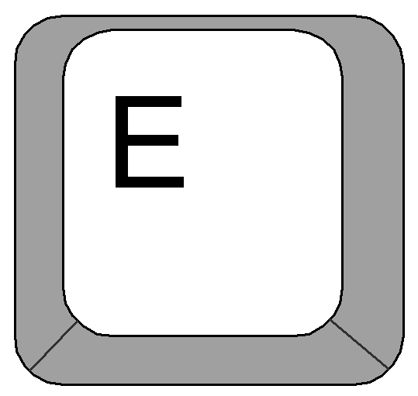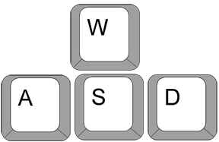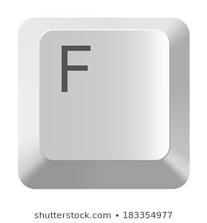

Movement keys

Quick-Time event key

Interact with patient

HOW TO PLAY

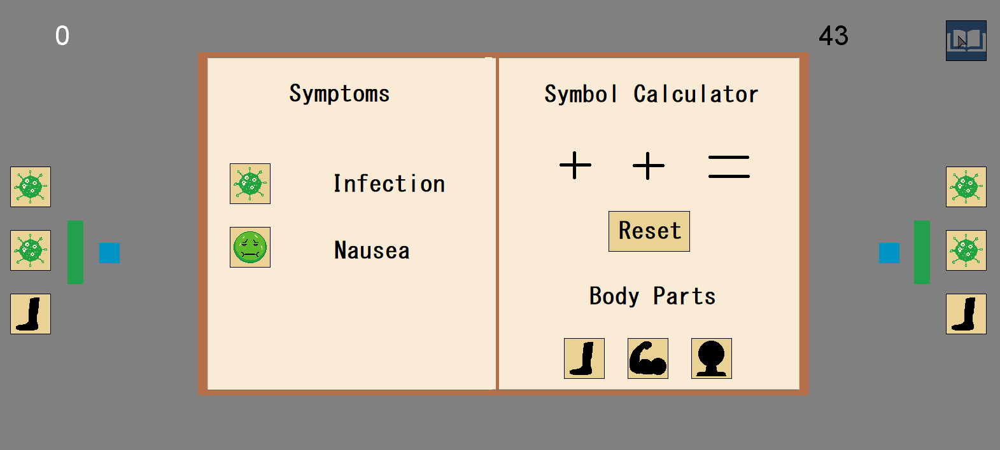

When you first enter the game, you will see several objects on the screen. For now, just click on the book symbol in the top right of the screen.

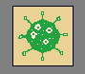This will open the handbook. Here you will want to look for the symbols next to the patients (blue square)

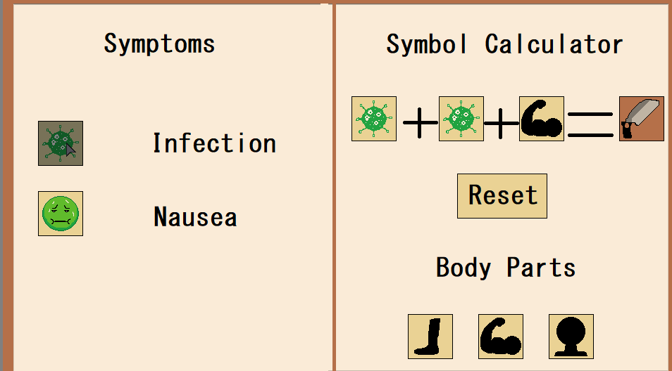

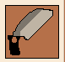Next, you will want to input the corresponding symbols into symbol calculator by clicking on the symbols on the handbook. You will see that the output of this calculator will be a tool symbol.

This tells you the tool you will want to grab from the toolbox.

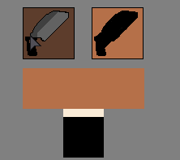

Walk over to the toolbox and click on the correct tool.

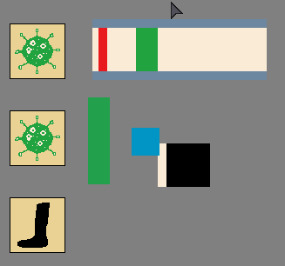

If something pops up that looks like this, then you have started the quick-time event. To complete this, press ‘e’ when the red line is on top of the green rectangle.

Walk over to the patient and press f (interact)

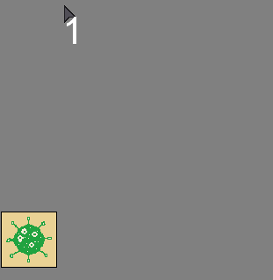

Doing this 3 times will add 1 to the score in the top left. Aim is to reach highest score before the timer in the top right runs out.

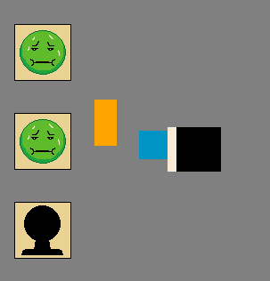

The other possible activity is the leech activity. If you picked a leech from the tool bench. Then interacting with a patient will start this activity. Interacting will take the leech on and off the patient. The aim of this is to leave the leech on the patient long enough to cure the patient, but to not let them die by leaving the leech on the patient too long. To take the leech off just interact with the patient again (press f) .



The timer will cause the game to restart when it reaches 0.